Glenn Lopez – Lab4

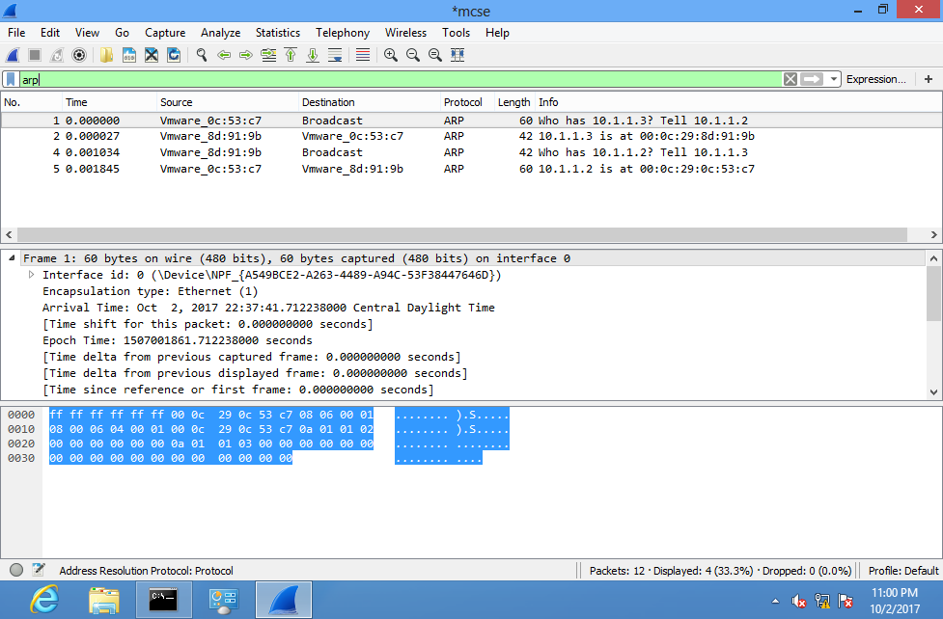  
#1a – Arp Packets

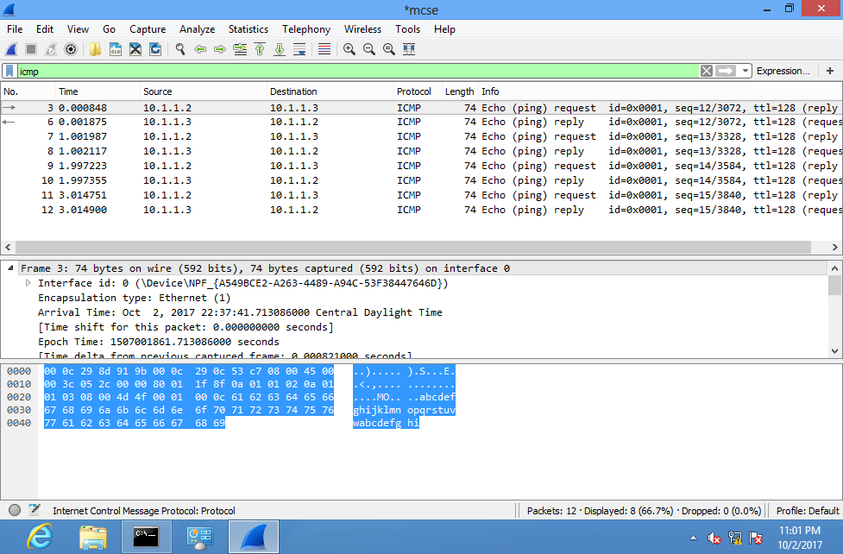

#1b – ICMP Packets

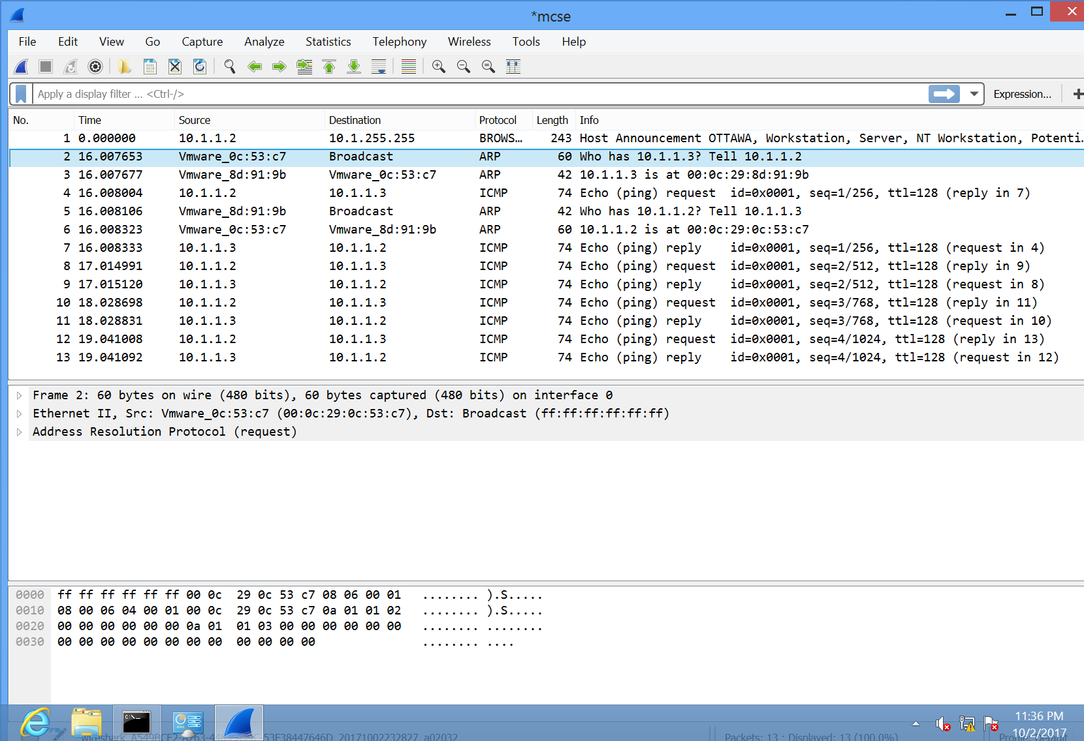

#2 – What is the purpose of the first frame:

* ARP resolves IP address to MAC address at the 2nd layer.
  + Frames on a local network are delivered to a MAC Address
  + Because of this:
    - A MAC address needs to be resolved from an IP address before a packet can be delivered
* The first frame (if it’s the broadcast ARP) asks “yells out loud” what MAC address has IP:xxx.xxx.xxx
  + Only then can a “PING” request will be sent

#3 – The OUI for VMWare is 00:0C:29 (<https://hwaddress.com/oui-iab/00-0C-29)>

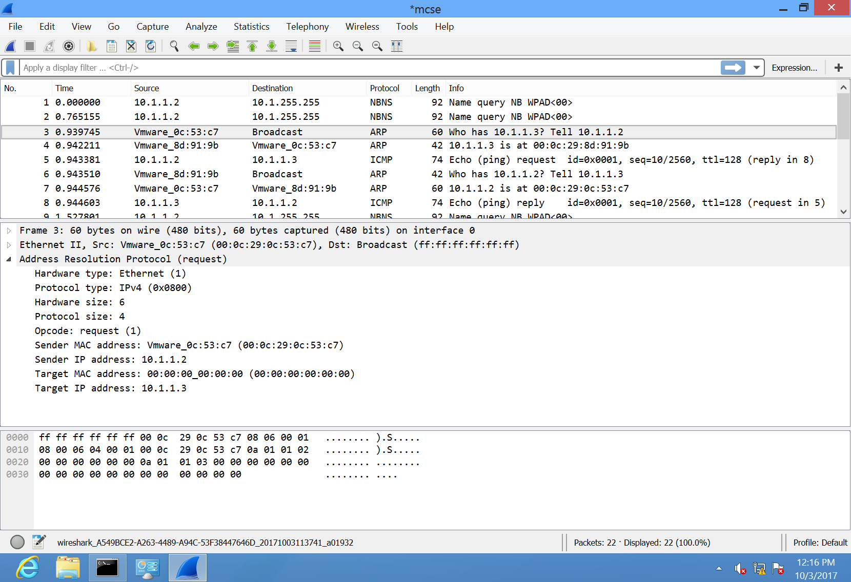

#4 – Expanded view of 1st ARP request

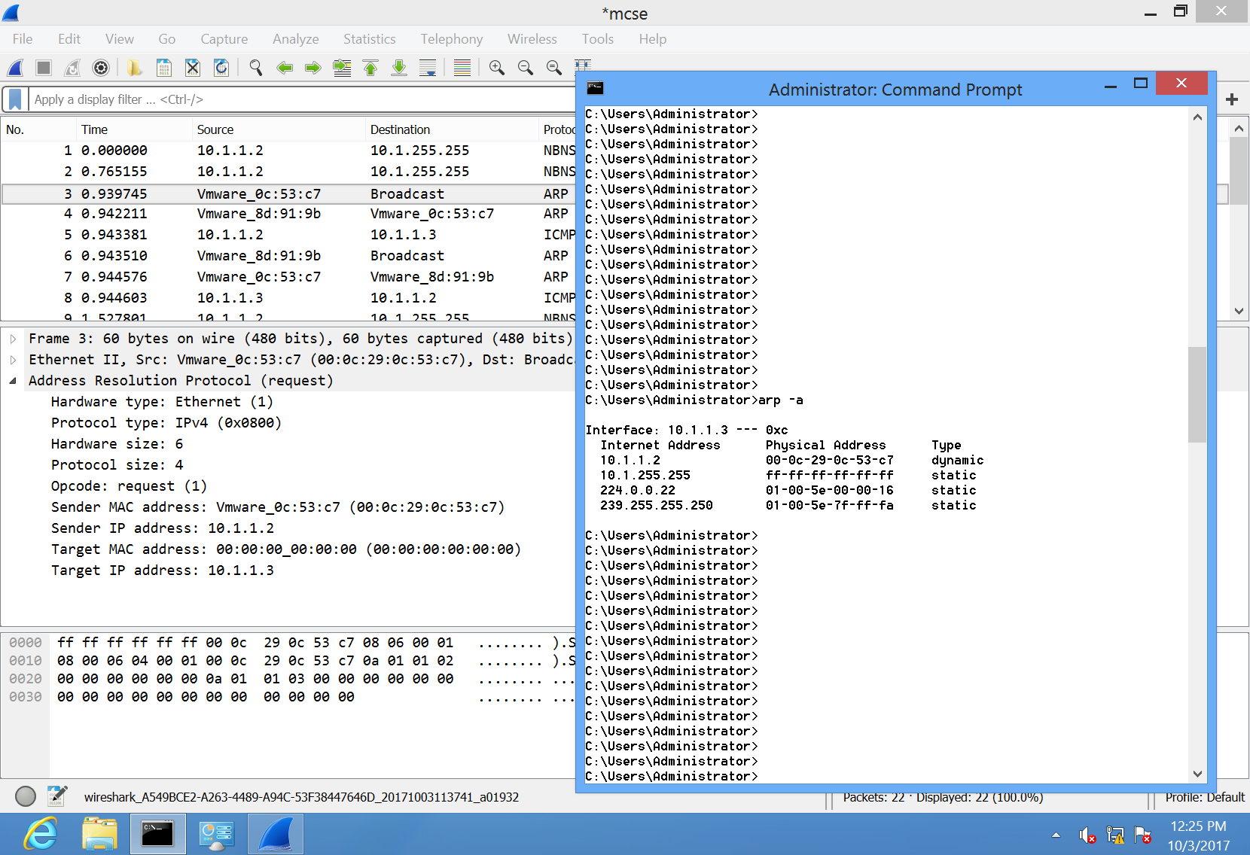

#5 – Display of the current ARP entries

#6 - ARP is used to connect OSI Layer 3 (Network) to OSI Layer 2 (Data-Link)

#7 – Purpose of frames 4 and 5 is the same as frames 1 and 2. When a Ping request is made to Hamilton, Hamilton needs to know where to send the reply. Since a MAC address needs to be resolved from an IP address before a Packet can be delivered, and ARP request to Ottawa is made for Hamilton to reply to Ottawa’s Ping request.

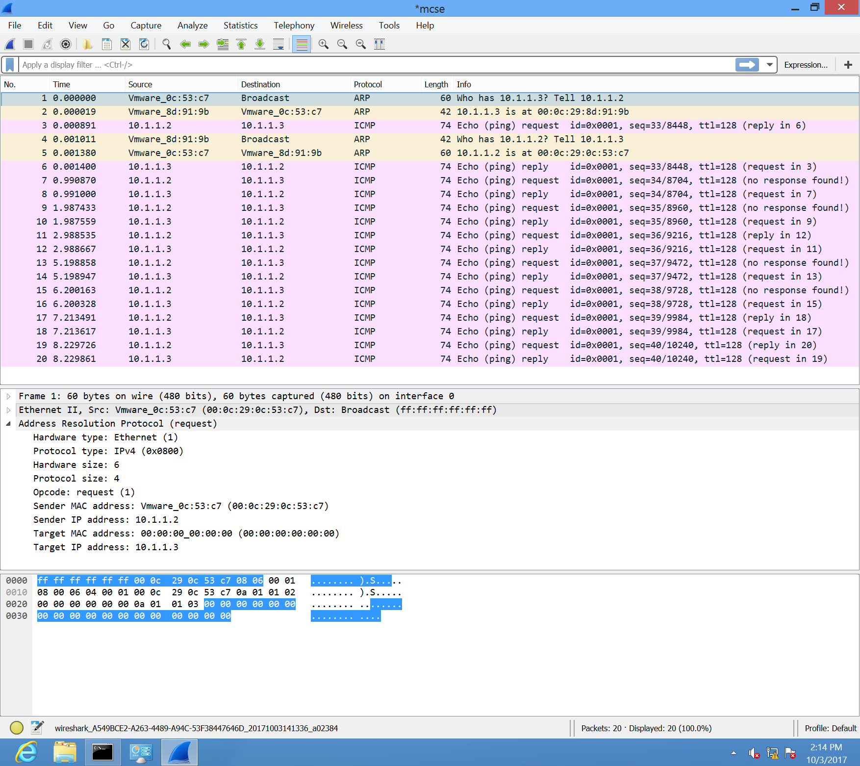

#8 – Second ping did not generate ARP request

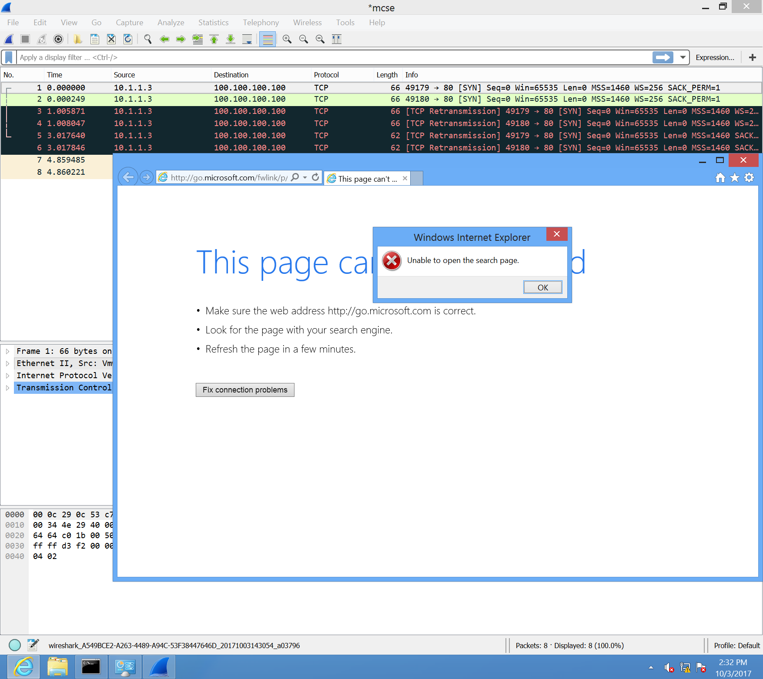

#NA – Hamilton trying to send frames to 100.100.100.100 with gateway configured to Ottawa’s IP